Monday January 25 Name ________________
Check your work!
1. Enter the product. Use an area model to prove your answer.
4238 x 32 =
2. Write the number in word and expanded form.

3.253

3, The rectangular prism shown has 4 layers with 6 cubes in each layer. Enter the volume, in cubic centimeters, of the rectangular prism.
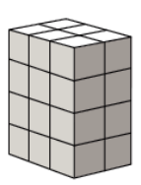
4. Which number makes this inequality true?

4253.647 > ___________
a. 4253.664
b. 4253.655
c. 4253.649
d. 4253.638

5. Jen measured the growth of a sunflower. In week one, it grew 2 ½ inches. In week two, it grew 2 ¾ inches. In week three, it grew 3 ¼ inches. How much did the sunflower grow over all three weeks?

Tuesday January 26
1. Use this pentagon to solve the problem. What is the perimeter in centimeters, of this pentagon?
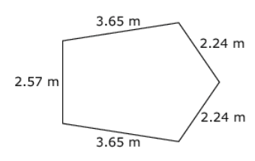
2. Write the number in word and expanded form.

12.502

3. Order the following numbers from greatest to least.

0.754 ; 1.754 ; 0.75 ; 0.753 ; 0.755

______________, ________________, ________________, _______________, ______________

4.
a. 0.9 + 0.8 =

b. 2.46 + 123.582 =

c. 93.29 + 8.3 =

5. This shape has four right angles.
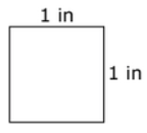
Which statement about this shape is true?

a. The shape is a rectangle but not a parallelogram.
b. The shape is a parallelogram but not a rectangle.
c. The shape is both a rectangle and a parallelogram.
d. The shape is neither a rectangle nor a parallelogram.

Wednesday January 27
1. Connor is buying tickets to a concert. The concert. The concert he and his friends was to see costs $4.75 per ticket. Conner has $26.00 total. What is the greatest number of tickets Connor can buy?

2. Write the number in word and expanded form.

0.82

3.
a. 0.6 + 0.8 =

b. 6.392 + 0.8 =

c. 83.6 + 7.392 =

4.
a. 0.11 - 0.7 =

b. 5.02 - 0.14 =

c. 85.123 - 5.15 =

5. Rename ¼ so it has a denominator of 16.

Thursday January 28
1.
a. 0.8 + 0.5 =

b. 7.056 + 0.3 =

c. 12.809 + 2.59 =

2. Write the number in word and expanded form.

138.015

3. Order the following numbers from least to greatest.

0.829 ; .82 ; 0.825 ; 0.820 ; 1.829

______________, ________________, ________________, _______________, ______________

4.
a. 0.15 - 0.9 =

b. 7.12 - 0.09 =

c. 62.984 - 9.42 =

5. Rename ¾ so it has a denominator of 24.

