Tuesday
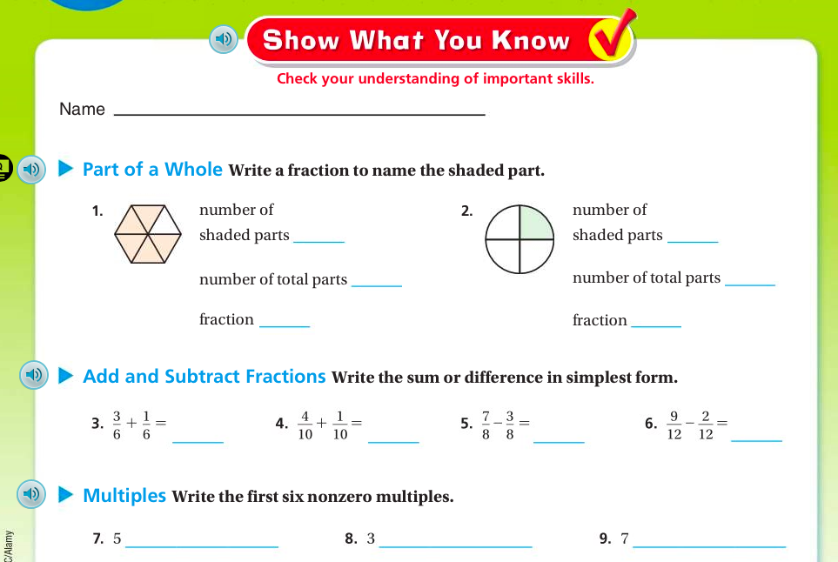
Wednesday September 7 Name ________________
Check your work! Final Answer
1. The diameter of the head of a screw is 0.306 inch. What is the number written in word and expanded form?
Word: _____________________________________________________________________________________________________________

___________________________________________________________________________________________________________________

Expanded: ________________________________________________________________________________________________________

___________________________________________________________________________________________________________________

2. When Mindy went to China, she exchanged $1 for 6.589 Yuan. What digit is in the hundredths place of 6.589? | 2.
3. Each car on a commuter train can seat 114 passengers. If the train has 7 cars, how many passengers can the train seat? | 3.
4. Use the number line below to mark the points 0 to 1 above the number line, and mark $\frac{0}{5}$ , $\frac{1}{5}$ , $\frac{2}{5}$ , $\frac{3}{5}$ , $\frac{4}{5}$ , $\frac{5}{5}$ below the number line. Then Draw two vertical lines to break each rectangle below into tirds. Shade the left third of each. Partition with horizontal lines to show equivalent fractions. Use multiplication to show the change in units. The first is done for you.
$\frac{1}{5}$ = $\frac{1 x 2}{5 x 2}$ = $\frac{2}{10}$

5. Use the number line below to mark the points 0 to 1 above the number line, and mark $\frac{0}{3}$ , $\frac{1}{3}$ , $\frac{2}{3}$ , $\frac{3}{3}$ below the number line. Then Draw two vertical lines to break each rectangle below into thirds. Shade the left third of each. Partition with horizontal lines to show equivalent fractions. Use multiplication to show the change in units. The first is done for you.
$\frac{1}{3}$ = $\frac{1 x 2}{3 x 2}$ = $\frac{2}{6}$

Thursday
1. What is the value of the expression [(29+18)+ (17−8)] ÷ 8? | 1.
2. For the following problems, draw a picture using the rectangular fraction model. Write your answer and Simplify.  $\frac{5}{6}$ + $\frac{1}{2}$ = |  | 2.
3. For the following problems, draw a picture using the rectangular fraction model. Write your answer and Simplify.  $\frac{1}{4}$ + $\frac{1}{3}$ = |  | 3.
4. Use the number line below to mark the points 0 to 1 above the number line, and mark $\frac{0}{4}$ , $\frac{1}{4}$ , $\frac{2}{4}$ , $\frac{3}{4}$ , $\frac{4}{4}$ below the number line. Then Draw two vertical lines to break each rectangle below into thirds. Shade the left third of each. Partition with horizontal lines to show equivalent fractions. Use multiplication to show the change in units. The first is done for you.
$\frac{1}{4}$ = $\frac{1 x 2}{4 x 2}$ = $\frac{2}{8}$

5. Use the number line below to mark the points 0 to 1 above the number line, and mark $\frac{0}{2}$ , $\frac{1}{2}$ , $\frac{2}{2}$ below the number line. Then Draw two vertical lines to break each rectangle below into thirds. Shade the left third of each. Partition with horizontal lines to show equivalent fractions. Use multiplication to show the change in units. The first is done for you.
$\frac{1}{2}$ = $\frac{1 x 2}{2 x 2}$ = $\frac{2}{4}$

