In 1492, Columbus Crashed a Ship in the Ocean Blue
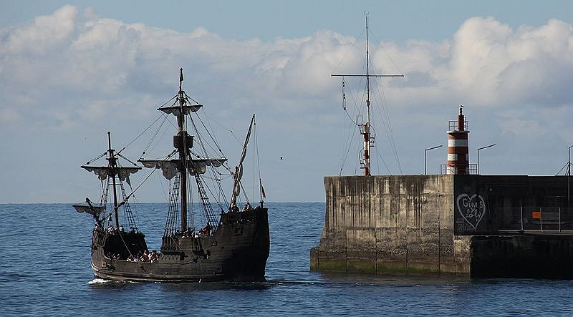
By Miami Herald, May 14, 2014

A 1998 replica of the Santa Maria in Madeira, an archipelago belonging to Portugal. Photo: Wikimedia Commons

MIAMI — An underwater explorer says he is certain that he has found Christopher Columbus’ long-lost Santa Maria.
The Holy Grail of shipwrecks, the Santa Maria was one of three ships that accompanied Columbus on his first voyage to the New World. Explorer Barry Clifford said he discovered the remains of Columbus' flagship near the coast of Cap-Haitien in northern Haiti. On Christmas morning in 1492, the Italian explorer who sailed for Spain reported in his journal that it was there that the Santa Maria had run aground. Years earlier, Clifford photographed what he now believes to have been a 15th-century wrought-iron lombard or cannon that has since disappeared. “There are only seven lombards that have been found in the Western world,” Clifford told the Miami Herald on Tuesday. “We found the eighth, exactly the distance where Columbus said he lost the Santa Maria.” The Santa Maria ship drifted into a coral reef and had to be abandoned. Columbus ordered sailors to build a fort nearby in Haiti before sailing the remaining two ships — La Nina and La Pinta — back to Spain to report what he had found.
A 500-Year-Old Riddle
The claim, which still needs to be verified, has its share of skeptics. One of them is another underwater explorer who also believed he had discovered the remains of the Santa Maria while snorkeling in 1987 off Haiti’s northern coast. “There is a lot of water, a lot of history around Haiti, and there have been many, many shipwrecks along the coast of Haiti,” said Daniel Koski-Karell. His 1991 journey to confirm his hunch was canceled because of turmoil in Haiti. Haiti's president was overthrown by the army. But should the scientific evidence of the wreckage pan out this time, the discovery would solve a 500-year-old riddle. The question of what happened to the Santa Maria has obsessed historians and marine archaeologists, and been the subject of many failed explorations. It would also raise the profile of a country struggling to rebuild four years after a devastating earthquake, and desperately trying to reshape its image in the world. “It would be a tremendous discovery for Haiti,” said Haitian Prime Minister Laurent Lamothe. Like others in the government, Lamothe isn't breaking out the champagne in celebration just yet. But Clifford is already envisioning a traveling exhibit of the wreckage. He said it would be “a positive statement from Haiti around the world.” He said, “This ship that changed the course of human history needs to be protected and preserved for the Haitian people. That is much more valuable than gold. This is an irreplaceable resource for the Haitian people.”
Exact Site A Secret
Clifford won’t provide the precise coordinates of the wreckage. But he did say it’s on a reef in less than 20 feet of water in an area not larger than two football fields. He is concerned, he said, that what’s left will be looted. He has asked Haiti to help preserve the site until a scientific diving expedition and underwater archaeological excavation can be conducted. They will help determine whether the materials are consistent with the late 15th-century ship. If research findings indicate that the shipwreck is likely the Santa Maria, a full excavation will be undertaken. This will be conducted with the permission of the Haitian government, which owns the wreck, Indiana University’s Office of Underwater Science said Tuesday. The university plans to conduct a full investigation, possibly as early as this summer, to determine whether the ship is the Santa Maria. “The evidence looks very compelling,” said Charles Beeker. He is a leading maritime archaeologist and director of the university’s underwater science program. Beeker recently joined Clifford on a expedition to the site. Clifford said he has discovered that the cannons had been looted. They were presumably “taken to the Dominican Republic and sold to treasure hunters,” he said. The cannons were first photographed in 2003 during an expedition of the site, but were misidentified by the team, Clifford said. It was only on further investigation of the photographs, he said, that he realized the shape was consistent with the Columbus-era vessel. Furthering his belief, he said, was the discovery of Columbus’ La Navidad fort in 2003, two miles from where previous archaeologists had looked. The wreckage is 4.7 miles from the fort. “It was precisely where Christopher Columbus said it would be,” he said of the Santa Maria. “It isn’t nuclear science.”
About Those Cannons ...
Columbus had written about the ship’s misfortune in his journal, which has become a treasure map for many a explorer. In it, Columbus told how his crew, with help from the native Indian population, had salvaged much of the ship and used the material to build a fort, La Navidad. It is precisely these details that Koski-Karell said make Clifford’s claim unbelievable. “Why would he leave cannons on the Santa Maria if he salvaged so extensively? There is a saying, in general, extraordinary claims require extraordinary evidence,” Koski-Karell said. Koski-Karrel also questioned how Clifford, whom he considers to be “a competent individual,” could misidentify a cannon of that period given its uniqueness. He said since his first visit to Haiti in 1977, he has returned many times. “To my knowledge, there has never been any conclusive proof Fort Navidad has been found,” said Koski-Karell. He is an expert on the archaeology of northern Haiti and conducted excavations with teams from the University of Florida. “I could possibly change my mind if I were allowed to review the evidence of it.” Clifford said more could be revealed after he revisits the site in June.

Week 3, Day 1: Read, Annotate (mini main idea for each paragraph in the margins), and Summarize the article.

Week 3, Day 2: Re-read the article, Annotate using a new color, and Cite evidence from the article to support you answer. Use R.A.C.E.S. How would you compare what you read about Christopher Columbus in this article, to what you have studied in the classroom and read in other hot topics? Use evidence from the text to support your answer.

