Cargo Drones Can Help Reduce Poverty
By Project Syndicate, adapted by Newsela staff
11.05.15
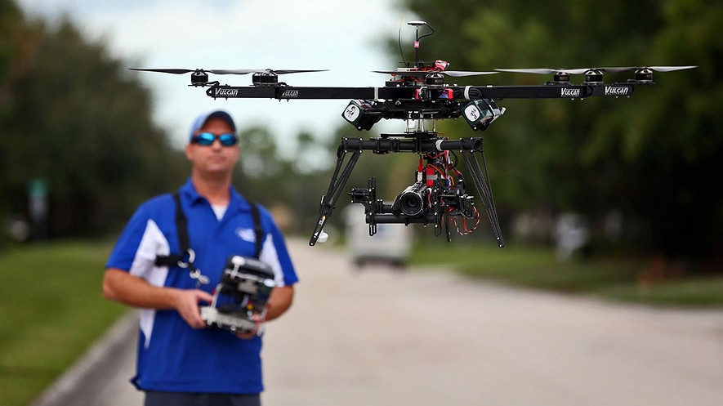
ReadyHeli.com technician and sales agent Brett Strand operates his own personal octacopter drone in Jupiter, Florida, Dec. 4, 2013. Photo: Richard Graulich/Palm Beach Post/MCT

LAUSANNE, Switzerland – Around the world, people are getting excited about drones, but fear them at the same time. Drones are like remote-controlled planes. Drones are also called unmanned aerial vehicles, or UAVs. They are piloted by onboard computers or remotely by a person on the ground. They can be used during war to gather information or shoot at an enemy from the air. They can also be used to deliver packages or take pictures of football games from the sky. People and drones already use the skies. That will not change. More than 3 million people fly in airplanes each day. Every large city on our planet is connected to another by planes.
Use Of Devices Will Grow
Drones that fly goods and packages are called cargo drones. They will be used even more around the world in the next few years. These drones do not weigh very much. They are cheap to fly but just as fast and safe as cargo planes. In rich countries, companies are interested in using cargo drones to deliver packages to a person's home. For instance, a drone could drop a tub of ice cream onto a front lawn. In poorer countries, drones can be used for more important things. About 800 million people around the world do not live near emergency services, like hospitals. It will not change anytime soon. There will not be enough money to build roads to connect faraway areas. By flying to many of these communities, cargo drones can save lives and create jobs.
Speeding Up Use Of Cargo Drones
Cargo drones are an example of what World Bank President Jim Yong Kim calls the “science of delivery.” The bank gives loans and advice to poor countries around the world. We know what we need to deliver. There are already solutions to many of the world's biggest problems. The question is how to do it. A group of people in Switzerland want to answer that question. They have joined together to start a new program called Red Line. Companies are just beginning to make emergency cargo drones. The Swiss group wants to speed this up so they can be used faster. It also wants to build the world’s first droneports, like airports for drones, in Africa. Technology often does not bring about real change in the lives of the poor. It is boring stuff like training teachers and health care that makes their lives better.
Sometimes, Cheaper Is Better
Sometimes, solutions that cost less work better. BRAC is a group in Bangladesh, a country near India. It is the world’s largest charity. BRAC has helped put 1.3 million children in schools, where there is hardly a laptop in sight. So why be hopeful about cargo drones? One reason is that they can work in remote areas of Africa, Asia and Latin America. In these areas, people are very poor and many people are sick. Also, villages are far apart, and roads might never be built.
In Africa, Drones Can Be Like Phones
Cargo drones are particularly good for reaching them. Companies and groups have trained women in hard-to-reach areas to start tiny businesses. They make sure their villages have what they need. It does not matter if they can even read. BRAC’s health workers, for example, sell health supplies and medicines in villages. Drones could deliver packages to these workers. Cargo drones will never replace ground transportation, like trucks and trains. Yet, they can get important goods to where they are needed. Mobile phones became popular in Africa. The technology was so much cheaper than building landline phone systems. Like the mobile phone, the cargo drone can be a gadget that works for those who need it most.

Week 6, Day 2: Read, Annotate (write in the margins: questions, circle unknown words, connections, main idea of each paragraph, etc. ), and Summarize the article.

Week 6, Day 3: Re-read both articles. Make a t-chart. On the left side record at least 6 reasons why drones are helpful and on the right side record at least 6 reasons why drones are helpful.

Week 6, Day 4: Re-read the article, Annotate using a new color to find evidence to answer the question, and Cite evidence from the article to support you answer. Write Multiple Paragraphs. The two articles this week present two different perspectives on drones. Overall, do you think drones are more helpful or harmful to the world’s population? Use at least three pieces of evidence from the article to support your opinion.
Drones Fly into Wildfires, Put Planes and First Responders at Risk
By Associated Press, adapted by Newsela staff
08.31.15

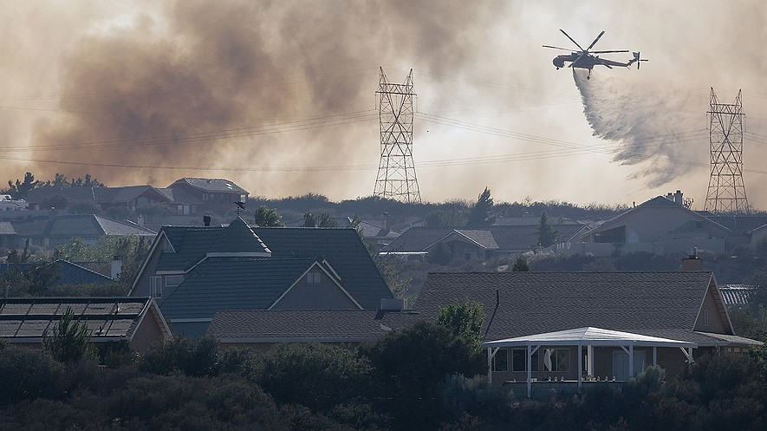
A helicopter works to put out a fire near Oak Hills, California, in July 2015. Photo: James Quigg/The Victor Valley Daily Press via AP, File

SAN DIEGO, Calif. — Helicopter pilot Jason Thrasher was fighting a fire in California. All of a sudden, he saw what he thought was another helicopter battling the blaze. He realized the object was a remote-controlled airplane, called a drone. It was only 10 feet from his windshield. He had to turn the helicopter sharply to avoid hitting it, according to a report. "If that drone came through my windshield, I have no idea what could have happened," Thrasher said. If the drone hit the tail, the helicopter could have crashed. The near-miss last September explains why firefighting pilots are worried. The problems have led to calls for more laws to keep drones away from firefighting aircraft. Drones are also called unmanned aerial vehicles or UAVs. They are piloted by onboard computers or remotely by a person on the ground.
Officials Suspect Drones Intruded 13 Times This Year
This year, there were 13 wildfires in which drones may have gotten in the way of firefighting aircraft. There were 11 since late June. Drones got in the way of only four fires last year. Last month, five drones at a wildfire forced aircraft to land for 20 minutes, while flames spread. "When you can't support firefighters on the ground, fires get bigger," said Ken Pimlott. He is the director of the California Department of Forestry and Fire Protection. "It's a huge issue." On Aug. 2, for the second time in three days, an airline pilot reported a drone while approaching a New York airport. On Aug. 9, four airplanes spotted a drone while landing in New Jersey. On Aug. 4, a drone got too near a fire in San Diego, California. The Fire Department pleaded with the drone operator to leave. They tweeted, "You are interfering" with firefighting. There is a simple explanation. Drones are getting cheaper, so more people are buying them. The Consumer Electronics Association predicts sales in the United States will reach 700,000 this year. About 430,000 drones were bought last year, compared to 128,000 in 2013. The group estimates this year's average price for a drone is $149. Drones cost $349 in 2013.

Lawmakers Seeking Stronger Laws To Stop Meddling
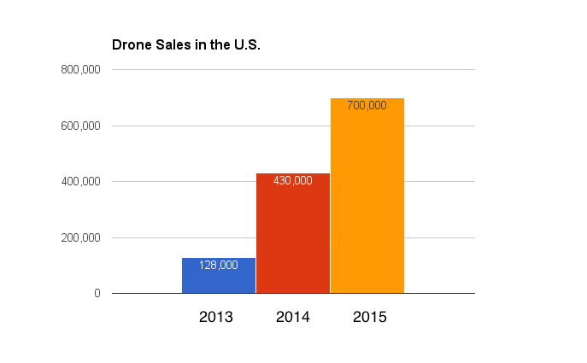
California lawmakers want stronger laws against drone owners who get in the way of firefighters. These laws would fine the drone owners and put them in jail. The lawmakers also want to let first responders destroy interfering drones. A first responder is a firefighter or police officer arriving at a fire or crime. Flying near wildfires is dangerous. Most drone owners probably do not know that, said Greg McNeal, a Pepperdine University professor and expert on drones. Others are just reckless, he said. Drones usually carry cameras, and drone owners may want to get pictures of forest fires in order to sell them.
5 States Had Possible Drone Sightings At Fires
The U.S. Forest Service reported possible drone sightings this year in 13 wildfires. California had eight. Washington state had two. Colorado, Minnesota and Utah each had one. A plane trying to put out a fire in California came near a drone on June 24. That meant four firefighting aircraft had to be grounded for 2 1/2 hours. An airplane spotted a drone on July 11. Pat McCabe is with the U.S. Forest Service. he was seated next to the pilot. McCabe saw the drone land about 3 miles from the fire. It was loaded onto an SUV. Its driver sped away.
Vehicles Barred From High Flight, Stadiums, Emergencies
The Federal Aviation Administration states that drones should fly no higher than 400 feet. They should stay away from stadiums and people. They also should avoid flying within 5 miles of airports. During wildfires and other emergencies, they cannot fly. Jon Resnick works for SZ DJI Technology Co. It one of the largest drone makers. People need to have common sense, he said.

Week 6, Day 1: Read, Annotate (write in the margins: questions, circle unknown words, connections, main idea of each paragraph, etc. ), and Summarize the article.

