Los Angeles in the Running to Host Third Olympics
By Associated Press, adapted by Newsela staff
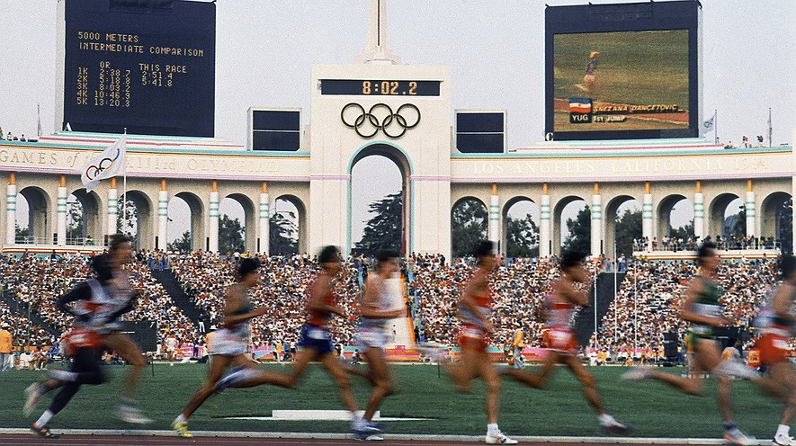
In this August 1984 file photo, competitors run in the men's 5,000 meter race at the Olympic Games in Los Angeles, California. The U.S. Olympic Committee selected Los Angeles as a replacement candidate for the 2024 games on Sept. 1. Photo: AP/File

LOS ANGELES, Calif. — The Olympic Games are the biggest sporting event in the world. Top athletes from almost every country on the planet take part. The games happen every two years, first in the summer and then in the winter. Each time they are held in a different place. It is a big honor to put on the Olympics. Many cities hope to be picked as the place where the Games happen. Each time, there is a contest that only one city can win. Cities have already been selected for the next four Olympics. None of them are in the United States. The race to put on the 2024 Summer Olympics is still on, though.
Now L.A. Faces Four Foreign Foes
On Sept. 1, Los Angeles came one big step closer to being picked. It has beaten out the other U.S. cities that were in the running. The U.S. Olympic Committee made the decision to select Los Angeles. Now L.A. will be matched up against Rome, Paris, Hamburg, Germany, and Budapest, Hungary. The International Olympic Committee will announce a winner in September 2017. Many were surprised that the U.S. Olympic Committee picked Los Angeles. Just two months ago the city seemed to be out of the running. Things started looking good for L.A. after Boston dropped out of the race. Boston's leaders decided that putting on the games would be too expensive for the city to handle.
L.A. Leaders Say City Will Do A Great Job
L.A.'s leaders are very happy their city was picked to represent the United States. Los Angeles was made for this, Mayor Eric Garcetti said. "This city is the world's greatest stage," he added. Los Angeles was home to the Olympics in 1932 and 1984. If the games are held in L.A. again in 2024, the city will do a great job, Garcetti promised. City leaders are confident Los Angeles will end up being picked to put on the games. "We are in this to win it, and I think we will," Councilman Paul Krekorian said. Not everyone is happy the Olympics might be coming to Los Angeles, however. Putting on the games costs a lot of money. A lot of new buildings need to be built, both for the games and for the athletes to live in.
Events Would Be Held All Over The L.A. Region
Over the years, staging the Olympics has often cost far more than expected. Russia is still paying for the 2014 Olympics, which were held in the Russian city of Sochi. The 2014 Olympics were the most expensive Olympics of all time. Los Angeles says it is prepared to spend $6 billion to put on the games. Events would take place all over the city. For example, volleyball games would be played on Santa Monica Beach, where the sport was invented. Mountain biking would happen in Griffith Park, one of the biggest city parks in the country. Memorial Coliseum would be the main playing field and stage, as it was in 1932 and 1984.The city says it will build a $1 billion athletes village if L.A. is picked. Athletes from around the world would stay there during the games, which last for more than two weeks.
Critics Are Worried About Costs
Los Angeles's leaders say the city can afford the cost of putting on the games. Not everyone is convinced, though. Some experts think the games could end up costing much more than planned. September 15 is the deadline for any city to enter the competition to play host to the 2024 Games.

Week 4, Day 1: Read, Annotate (mini main idea for each paragraph in the margins), and Summarize the article.

Week 4, Day 2: Re-read the article, Annotate using a new color, and Cite evidence from the article to support you answer. Write Multiple Paragraphs. Should the Olympics be held in Los Angeles? Use at least three pieces of evidence from the article to support your opinion.

