How's This for a Classroom Exercise?
By Chicago Tribune, adapted by Newsela staff
10.05.15
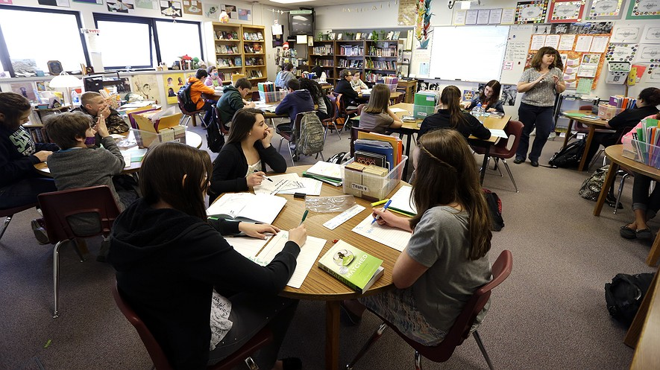
TOP: Annette Wells (right) leads a discussion in her seventh-eighth grade language arts class at Komachin Middle School in Lacey, Washington, April 18, 2014. Photo: AP Photo/Ted S. Warren. BOTTOM: Students at Windsor Elementary School in Arlington Heights, Illinois, including Adam Boesen, 10, are learning this year with the help of fit workstations. Photo: Karen Ann Cullotta/Chicago Tribune/TNS
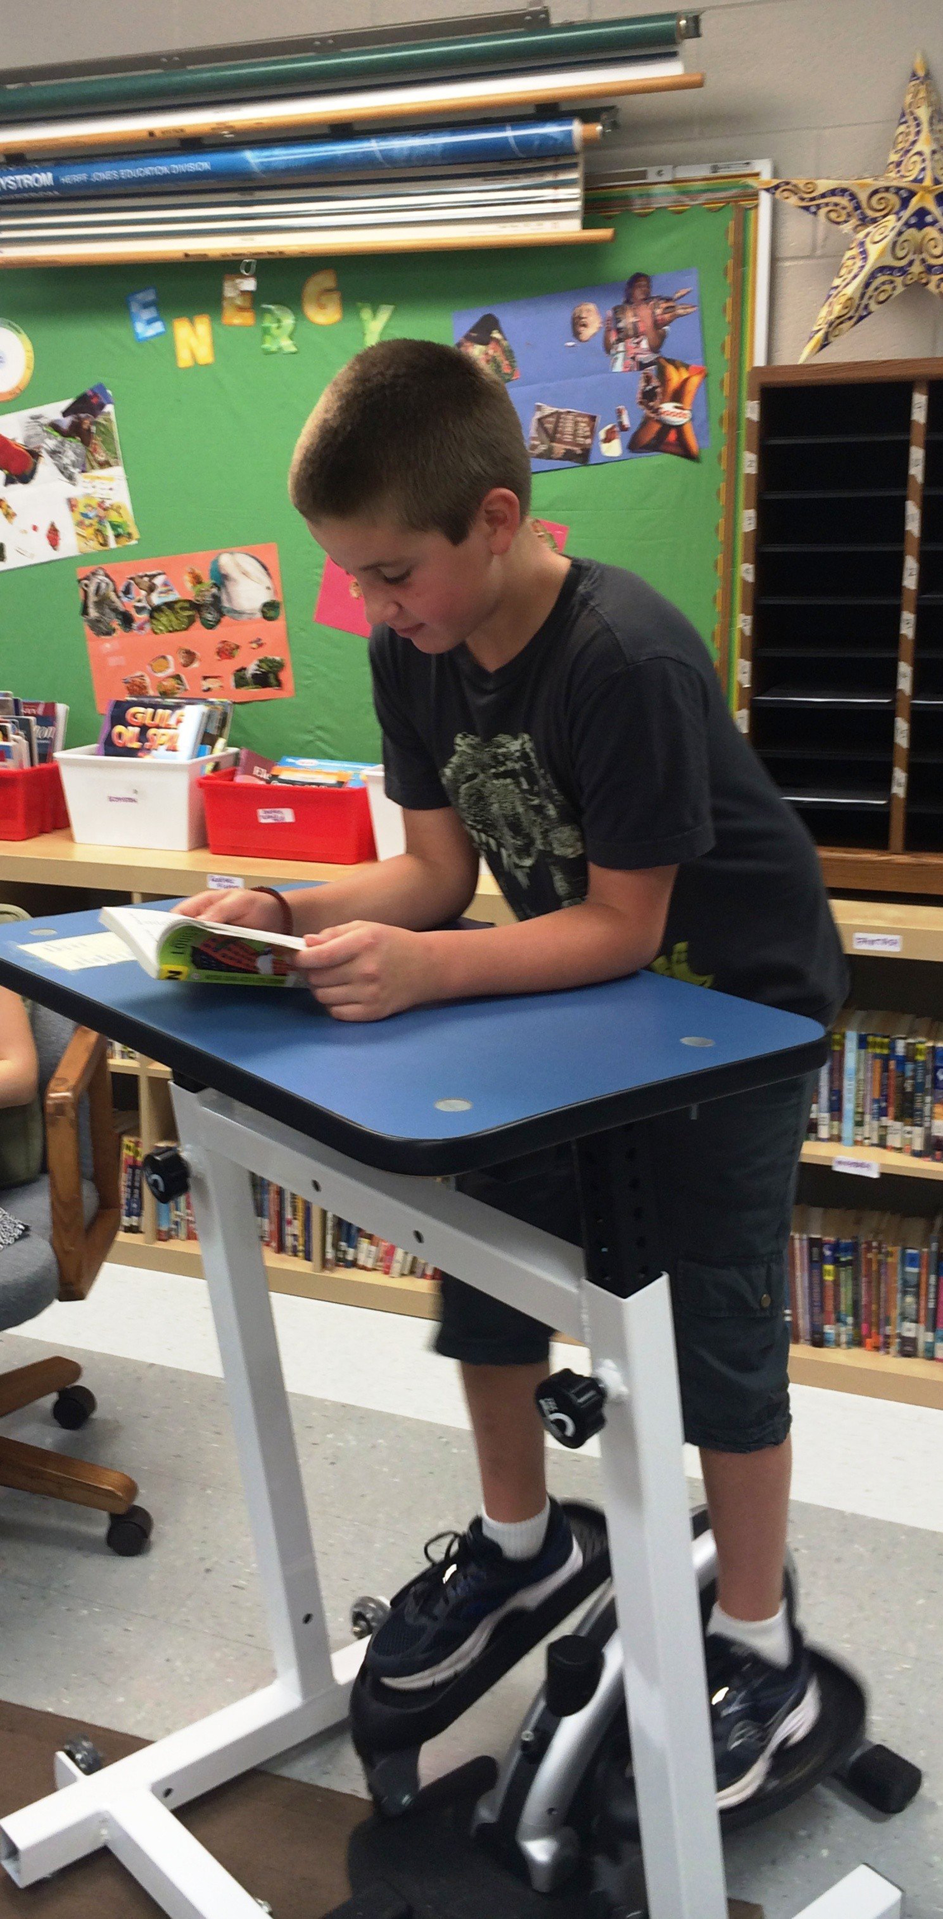
ARLINGTON HEIGHTS, Ill. — For years, students were told to “sit still" at their desks. Now, that has changed with the addition of exercise machines to classrooms at an elementary school near Chicago. On a recent morning at Windsor Elementary School, Adam Boesen, 10, hopped aboard one of the machines. It was not during gym class. Adam got his exercise while participating in silent reading time. “It helps me concentrate,” said Adam. He kept up a brisk pace on the elliptical, a machine that lets people move their arms and legs to stay fit. At the same time, he was deep into reading a book by Louis Sachar.

Biking And Bouncing While Learning
“I got my homework done early the other day,” added classmate Joshua Grzesiak, 10. He said the so-called "fit work stations" also help him stay focused. “When I’m on the elliptical, I feel the opposite of distracted," he said. "I’m more connected with what I’m learning than when I’m just sitting.” Welcome to Windsor’s new fit classrooms. Principal Shelley Fabrizio researched ways of educating students that are meant to get them involved in learning. Now she has encouraged her staff of kindergarten through fifth-grade teachers to allow students to bike, bounce and even pedal while learning. “We all know that kids love to move, so we didn’t want to have our students sitting all day long,” said Fabrizio. The principal worked with Assistant Principal Virginia Hiltz. They created a program with standing desks, stationary bikes and elliptical desks. There is also a rainbow-colored stool called an Ergo chair. The chair looks like something out of Willy Wonka. The workstations cost about $3,635 each. Hiltz said work stations were rotated throughout the school’s classrooms last spring to give every student the opportunity to experiment with at least one piece of equipment. Students were then surveyed so teachers could learn which work stations were most popular. “Some of the pieces were a huge hit, and others weren’t as popular,” Hiltz said. “But the bottom line is that students loved the chance to test them out. Many even said they were able to concentrate and focus more on academics while using the equipment, and that’s what we were after.”

"Work Where They Want To Work"
The survey results showed that the Ergo chairs were a favorite of a majority of students. So officials used funding from the school’s Parent Teacher Association (PTA) to purchase six additional chairs. All appeared to be happily occupied during a recent visit to several classrooms.
“So many kids have attention needs, and they all have different approaches to learning,” Hiltz said. She added that students can choose whether to use a fit workstation or stay seated at a traditional table or desk. “I started out with standing desks, one per classroom,” Hiltz said, “and the kids and teachers just loved them … the teachers wanted some for themselves." The program expanded from there, she said. Christina Philo teaches fifth grade at the school. Philo said that when the new fit workstations first arrived in her classroom, she was not surprised that her students reacted enthusiastically. “I knew the kids would be excited and wild, and they all ran over to the elliptical,” Philo said. “So I created a schedule for each piece of equipment that lists all of my students’ names, and when everyone has had a turn, it starts over again." Philo added, “For my more active students, being able to stand while they learn is especially important. Before, they would be wandering the room and not as focused, but now, these new desks let them work where they want to work.”

Week 5, Day 3: Read, Annotate (write in the margins: questions, circle unknown words, connections, main idea of each paragraph, etc. ), and Summarize the article.

Week 5, Day 4: Re-read the article, Annotate using a new color to find evidence to answer the question, and Cite evidence from the article to support you answer. Write Multiple Paragraphs. Is it beneficial to have exercise machines in the classroom? Use at least three pieces of evidence from the article to support your opinion.

