As Brazil Builds Stadiums for Olympics, Poor People Worry About their Homes
By Miami Herald, adapted by Newsela staff
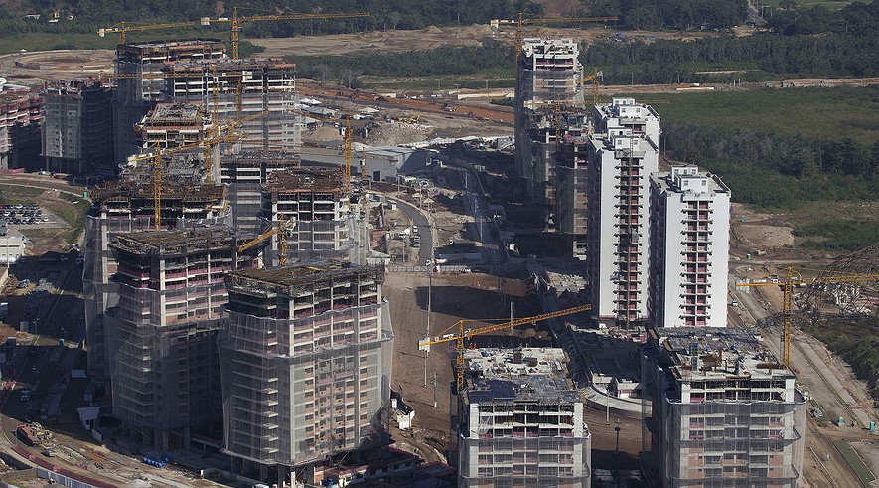
This June 27, 2014, photo shows the Athletes Village under construction ahead of the Rio 2016 Olympic and Paralympic Games in Rio de Janeiro, Brazil. Photo: AP Photo/Leo Correa

RIO DE JANEIRO — The Summer Olympics are held every four years in a different city. In 2016, they will take place in Rio de Janeiro, Brazil. Recently, the president of Brazil, Dilma Rousseff, visited the place that will become Olympic Park. She promised that the games would be a great success — or, as she put it, “the Olympics of all Olympics.” The president said the Olympics would benefit from Brazil’s experience organizing the World Cup soccer tournament. The final match of the Cup took place in Rio in July 2014. Brazil's handling of the Cup drew widespread praise. However, memories of what happened in Rio during the buildup to the Cup terrify some Brazilians. The people worried most are those who live in poor communities known as favelas.
Neighborhoods Disrupted
The World Cup went very smoothly — except for those who live in the favelas. Their neighborhoods were disrupted. They are worried they will see the same kinds of problems again during preparations for the Olympics. Events like the World Cup or the Olympics bring a huge number of tourists from all over the world. New stadiums, buildings and roads are often built. Whole neighborhoods can go through big changes — even if the people living there don't want them. One of the favelas, Favela do Metro, is located just 300 yards from the Maracana soccer stadium. World Cup games were held at Maracana. Olympic games will be held there as well. People in Favela do Metro say they were mistreated during preparations for the World Cup.
Knocking Down Houses
City officials wanted to build a new parking lot in the favela, near Maracana stadium. In 2010, the city started knocking down houses. Many families were forced to leave. Then, with no reason given, the city just stopped. No new parking lot was ever built. For the people who remain in Favela do Metro, things are now much worse than they ever were. The city seems to have forgotten about them. Rats roam freely. Mounds of garbage and old furniture pile up. Some houses are still standing, but are surrounded by houses that have been destroyed. The neighborhood now looks like it has been bombed. People have no running water. A desperate cry for help is scrawled on one wall: “We are not animals to be discarded in this way.”
Officials See Things Differently
City officials describe events in Favela do Metro differently. One official said that people agreed to leave and had plenty of notice. Many were moved to new housing, she said. Others who gave up their homes got money from the city, she added.
However, many deny those claims. They say the people of Favela do Metro were given very little time to leave and many were mistreated by the police.
For those who remain in Favela do Metro, things are only getting worse. Barbara Cabral Souza, age 38, says that city officials have yet to offer her a way out. The shops and jobs that were once here are gone. There is no police presence, and drug dealers have become her neighbors. “We are prisoners inside our own city,” she said.

Week 4, Day 3: Read, Annotate (mini main idea for each paragraph in the margins), and Summarize the article.

Week 4, Day 4: Re-read the article, Annotate using a new color, and Cite evidence from the article to support you answer. Write Multiple Paragraphs. Is having the Summer Olympics beneficial or not for Brazil? Use at least three pieces of evidence from the article to support your opinion.

