Should Fast-Food Workers be Paid More?
By McClatchy-Tribune, adapted by Newsela staff
12.06.13

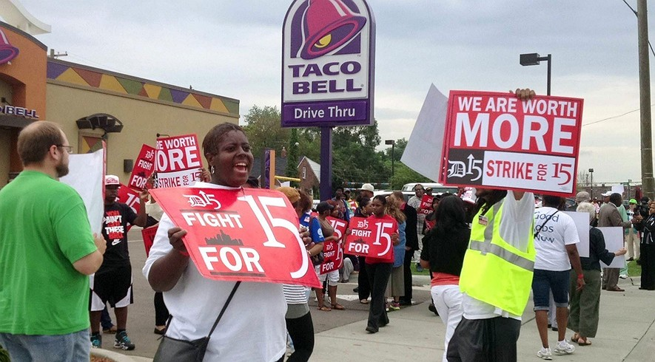
Supporters of Good Jobs Now, along with fast-food employees, rally in front of Taco Bell on 8 Mile and Dean in Warren, Mich., Wednesday, July 31, 2013, for better wages. Most employees make $7.40 an hour. Photo: Jessica J. Trevino/Detroit Free Press/MCT
PRO: Higher wages for fast-food workers important
WASHINGTON – Last November, fast-food workers began demonstrating for higher pay. These workers are some of the nation's poorest employees. Anyone who cares about fairness should support them. First, let's throw out some of the nonsense that people say about these workers. They are not mostly teenagers working for pocket money. Most of them are at least 23 years old and more than a quarter of them are raising at least one child.
Not Enough Jobs
How are they supposed to survive on about $9 an hour, which is their average wage? The lowest amount you can be paid, the minimum wage, is $7.25 an hour. Many only make that. Clearly, they are not just working at these jobs for a short time and then moving on to higher pay. In America, there are a lot of jobs for low-skilled workers. There are jobs for people who went to college. There are not enough jobs for people in between. Fast-food workers are suffering for the same reasons that most workers are. They have been making less and less money over the years. The government wrote the rules of how companies can work. They wrote them in a way to help businesses make more money. But the rules do not pay attention to the workers. The very richest Americans are making much more money than they did 30 years ago. They are not getting richer because of changes in technology or because they have the most needed skills. They are making more money because the rules have changed. If pay had gone up since 1968 the way it did for many years before then, the lowest wage someone could take home would be $17 an hour today, not a measly $7.25.
Time For A Change
People are not getting paid as much because of what were called government "reforms." Some of the changes made it easier for companies to make their goods overseas. In some of these other countries, people will work for less money. These reforms made our country less stable financially. Now, these fast-food workers are telling us that it is time for a change. This kind of mass protest around national economic issues has not been seen for a long time. The last time might have been the Great Depression. Obama and his allies just tried to drag the country into another war. They failed, because Americans showed the Congress that they were sick and tired of senseless wars. Maybe we should make the government understand that we are also sick and tired of a country that gives more to fewer and richer people each year. We are sick of a country that leaves millions of people struggling to get by. Then we might begin to right some of the wrongs in America.
CON: Higher wages for fast-food workers harmful
WASHINGTON – During the Middle Ages, doctors stuck leeches onto their sick patients to suck their blood. But the strange treatment only made the sick sicker. Today, people are trying to help fast-food workers. They want to raise their wages to $15 an hour. The problem is, it will only hurt them. In America, minimum-wage workers get paid more than workers in Mexico. Why? It's not because U.S. companies are more generous than Mexican companies. Nor do Americans somehow deserve better pay. American minimum-wage workers earn more because they produce more. They are able to produce more because they are better educated. Also, the companies they work for have more money available to buy better equipment. These two facts put together mean American workers can get more done and earn more for their work.
Paid What You're Worth
Businesses have to pay productive workers well. If companies pay less, those productive workers will just jump ship and go work for another company. That's what competition is all about. However, if they pay workers more than they produce, companies will just go out of business. The fact is, fast-food jobs are relatively low-productivity jobs. The work is usually done by inexperienced workers. Most fast-food customers want a quick, cheap meal. They will not pay top prices for a burger and fries, at least not all the time. Doubling McDonalds' wages would raise its total costs by one-quarter. If it kept prices steady, the company would not make any profits on its sales. But raising prices would drive customers away. If Congress forced fast-food restaurants to pay $15 an hour, they would have to get a lot more productive to offset those higher costs. That would mean replacing current workers with machines. The technology is ready. Customers could use self-serve iPad stations to enter their orders. There's a robotic burger flipper that makes up to 400 hamburgers an hour. Restaurants could install one to replace several workers at once. These high-tech improvements are costly, but they would make sense for restaurants to buy them if wages doubled. The end result: far fewer jobs for humans in the fast-food industry. Those who think such a trade-off is worthwhile miss the point of minimum-wage jobs. For most workers, they are entry-level positions. Starter jobs like these are where they can gain experience that makes them more productive and helps them get better pay in their next job. Businesses look for skills like reliability, self-control and the ability to follow instructions. Fast-food jobs train new workers in these basic skills.
Starter Jobs Would Disappear
Most Americans started out earning near minimum wage at their first job. Few stay there long. The average fast-food employee stays at his or her restaurant for less than a year. This is the first step on a career ladder. That is why most fast-food workers are under the age of 25. Super-sizing fast-food wages would make many of these starter jobs disappear. Young people would have a hard time getting on to the ladder of success. Most lawmakers and leaders understand this. No state has a minimum wage anywhere near $15 an hour. But American Samoa is an example of would happen if the supporters of the $15 an hour plan get their way. The island territory of American Samoa used to have a separate minimum wage because of its lower incomes. However, in 2007 Congress told American Samoa it must follow the U.S. minimum wage. For the tiny Pacific Ocean nation this was equal to $20 an hour. It did not boost people's ability to buy more goods. It didn't increase the demand for goods and services. Nor did it improve the way people live. Instead, unemployment skyrocketed, leaving more than 35 percent of the islanders jobless. Business growth and spending in American Samoa collapsed. The islands' governor begged Congress to stop the wage hikes, pleading: "Our job market is being torched. Our businesses are being depressed. Our hope for growth has been driven away. How much does our government expect us to suffer?" When it comes to money, you can't interfere with the balance between what things cost and what people will pay for them. That balance isn't like some government law you can just undo. There will be unwanted results, even if you mean to do good. Boosting fast-food wages would make thousands of starter jobs disappear. Just like leeches didn't help sick patients in the Middle Ages, this plan won't help today's fast-food workers.
Week 9, Day 1: Read, Annotate (write in the margins: questions, circle unknown words, connections, main idea of each paragraph, etc. ), and Summarize the article.

Week 9, Day 2: Re-read, Annotate using a new color to find the answer to each multiple-choice question. Next to the text annotation, write the question number.

Week 9, Day 3: Re-read the article. Make a t-chart. On the left side record at least 6 reasons why higher wages for fast-food workers is important and on the right side record at least 6 reasons why higher wages for fast-food workers is harmful.

Week 9, Day 4: Re-read the article, Annotate using a new color to find evidence to answer the question, and Cite evidence from the article to support you answer. Write Multiple Paragraphs. In your opinion, should fast-food workers be paid more? Use at least three pieces of evidence from the article to support your opinion.
Day 2

1. What do both sides agree on?
a. Fast-food workers are not paid very much money.
b. Laws took power away from poor people.
c. Robots will replace fast-food cooks.
d. The rich people keep getting richer.

2. The two authors agree on all of the following things EXCEPT:
a. Fast-food workers are often young.
b. Fast-food workers do not make a lot of money.
c. Fast-food workers should be paid more.
d. Fast-food workers could be replaced by technology or cheaper workers.

3. Select the sentence that would fit best in the PRO article:
a. Fast-food workers could soon be replaced by technology like iPads or computers.
b. If we raised pay for fast-food workers, we could end up like American Samoa.
c. The wages for fast-food workers have been too low for a long time and it needs to stop.
d. Fast-food workers in America are making even less than workers make in Mexico.

4. Select the sentence that would best fit in the CON article:
a. Fast-food workers are not being paid enough in Mexico.
b. If we raise the wages for fast-food workers in America, everyone will suffer.
c. If we raise the wages for fast-food workers, it will right a system that has been wrong for years.
d. Fast-food workers are being paid too much in America because they do not work hard enough.

