Putting GMO Information on Our Food Labels
By Tribune News Service, adapted by Newsela staff
11.13.15

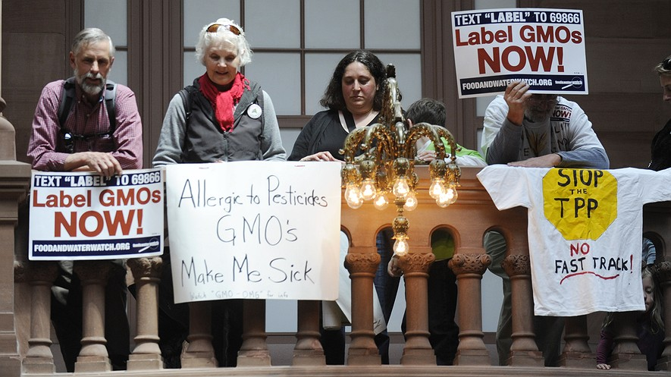
Demonstrators rally in favor of labeling GMO food at the Capitol in Albany, New York, April 28, 2015. Photo: AP Photo/Tim Roske

PRO: Many believe GMOs unsafe, want them labeled
Health and food safety are scary subjects for millions of Americans. They should be.
Polls show Americans are alarmed over what's in their food. Americans are worried about pesticides, antibiotics, hormones and other unnatural things added to food. They are especially concerned about genetically modified organisms (GMOs). GMOs are plant or animal products. They have been created by scientists in a lab. They use DNA from bacteria, viruses or other plants and animals. The purpose is to make seeds produce more or stronger crops. The crops can be more resistant to insects and low rainfall. A recent poll found that 93 percent of Americans want GMOs labeled. Already, 64 nations require such labels.

Buying Non-GMO Food
Two-thirds of Americans believe that GMOs are unsafe. Millions of Americans are switching over to non-GMO, organic foods. Indeed, Americans now spend more on organic food. More than 10 cents of every dollar Americans spend on food and drink is for products labeled “organic,” “non-GMO” or “natural.” GMO labeling laws were voted on in California, Washington and Oregon. The big food companies like Coca-Cola spent millions of dollars to sway voters. Chemical companies did, too. Monsanto, the world’s largest maker of genetically modified seeds, spent millions. They were successful in stopping these labeling laws from passing. Vermont, Maine and Connecticut have passed laws requiring the labeling of GMOs.
Vermont’s GMO labeling law goes into effect in July 2016. Already, it is causing major food brands to panic. They know they've got a problem. They have to make a choice. One option they have is to remove all GMO ingredients from their products. That's exactly what happened in European countries after GMO food labeling became required in the European Union in 1998. The other choice by food companies is to add a GMO label on the front of their packages and bottles. Eighty percent of supermarket foods now contain GMOs. They also contain the toxic chemicals sprayed on GMOs.

Dangers Of One Herbicide
In March 2015, the World Health Organization of the United Nations (WHO) studied Monsanto’s Roundup herbicide. It is made from glyphosate. The WHO said it probably causes cancer. That prompted several dozen countries to stop the use of GMOs in farming. The state of California agrees about the danger. It added Monsanto’s herbicide to its list of cancer-causing chemicals. In the United States, glyphosate herbicide is sprayed heavily on most GMO crops. Corn, soybeans, beets, wheat, beans and rice are all sprayed with it. The U.S. Environmental Protection Agency (EPA) has said that over time glyphosate can damage the kidney and reproductive organs of humans. And a scientific report last year connected glyphosate to damage to the human gut and digestive system. Glyphosate use has also resulted in uncontrollable, herbicide-resistant superweeds on much of U.S. farmland. Meanwhile the EPA, U.S. Department of Agriculture (USDA) and the Food and Drug Administration (FDA) have given the green light to a scary new generation of GMO crops. They are allowed to be sprayed with strong toxicides. One of these was used to destroy crops and forests during the Vietnam War. Billions of pounds of glyphosate and other toxic pesticides are now being sprayed on our food. They prevent insects from ruining crops. In addition, billions of pounds of chemical fertilizers are added to crops. They help them grow, sure. Yet they pollute the environment at the same time.

Our Health Is At Risk
GMOs and the chemicals used on GMO crops are destroying our health. They also poison our soil, water and air. Americans want GMO labeling. Unfortunately, Monsanto and the other big food companies don't want that. Working with them are the members of Congress who receive money donated by those companies. Right now, Congress is considering a law. It is called the Safe and Accurate Food Labeling Act of 2015. It would take away the rights of states to require labels on GMO foods. The law would also let GMO foods be labeled as “natural.” This is wrong.
Americans can help stop this law from passing. Tell Congress you want labels on GMOs.

CON: GMO foods are safe, no need for labels
Eighty percent of supermarket foods now contain genetically modified organisms (GMOs).
But labeling these foods is certainly not about food safety. No humans have been harmed by GMO products — ever. And it’s also not something that the Food and Drug Administration (FDA) can legally do right now. There is no scientific difference between GMO foods and regular foods. By the year 2025, the World Wildlife Fund (WWF) estimates that two-thirds of the world’s population will confront a water shortage. Ecosystems will also suffer. Food will become harder to grow. One way to make this scenario less dangerous to our food supply is to use GMO foods. They reduce the need for plowing fields. This allows the soil to stay moist. Then plants can retain more water. In some cases, this will make the difference between a harvest or crop failure. Results show crop yields increasing significantly.
Right now, nearly 1 person in every 9 does not have enough to eat on this planet. GMOs can help.

GMOs Mean Fewer Pesticides
Another way that GM foods help us is that they use less pesticide. One study found that it reduced the amount of pesticides and their costs by more than one-third. Pesticides get a bad rap. They don't deserve it. The truth is that there are only tiny amounts of pesticides in the foods you eat. You are totally safe. Toxicologists study how chemicals affect living things. As one put it, there are more cancer-causing substances in a single cup of coffee than there are in all the small amounts of pesticides you eat and drink in a year. That doesn’t mean that coffee will give you cancer. All it means is that there are very few pesticides in what we eat and drink.
An increase in crop yield and a decrease in pesticide costs will lower the price of food. That’s a good thing, particularly if you don't have much money. It’s amazing people are even fighting over GMOs. They have been around for 20 years. In fact, people have been changing food genes forever. GMO crops are just a newer version of natural plant breeding that began more than 8,000 years ago. Back then, farmers bred plants by choosing the best ones to save for planting in the following year. The corn we eat today, for example, is the result of genetically modified plantings from thousands of years ago. Within the last few hundred years, farmers began mating or cross-pollinating plants to grow more crops.

We Can't Afford To Label GMOs
GMO foods are no different. They just use modern technology. GMO foods also allow scientists to tackle certain problems with crops. These crops produce foods that keep better. They spoil less from mold, don't cause allergies, and can even grow medicines in them. Take the example of Golden Rice. It is a GMO food that contains beta carotene (Vitamin A) which helps to reduce blindness. It even prevents up to 2 million deaths annually in poor countries.
Labeling GMO products would be expensive. It could also discourage companies from making better GMO seeds. Labels may seem like a simple way to share information. Yet they will cost food companies more. That will force them to raise food prices. Many people simply cannot afford that. Those who wish to buy non-GMO foods can buy organic. However, if you buy organic, you are actually putting yourself more at risk. Organic foods are four to eight times more likely to be contaminated with microbes. And for that, you are paying a lot more.

Week 7, Day 1: Read, Annotate (write in the margins: questions, circle unknown words, connections, main idea of each paragraph, etc. ), and Summarize the article.

Week 7, Day 2: Re-read, Annotate using a new color to find the answer to each multiple-choice question. Next to the text annotation, write the question number.

Week 7, Day 3: Re-read the article. Make a t-chart. On the left side record at least 5 reasons why many GMO’s are unsafe and should be labeled and on the right side record at least 5 reasons why GMO’s are safe and do not need to be labeled.

Week 7, Day 4: Re-read the article, Annotate using a new color to find evidence to answer the question, and Cite evidence from the article to support you answer. Write Multiple Paragraphs. In your opinion, are GMO’s safe or unsafe? Should they be labeled or not labeled? Use at least three pieces of evidence from the article to support your opinion.
1. What is the purpose of the section "Dangers Of One Herbicide" in the PRO article?
a. to outline the many uses of a specific herbicide
b. to argue why companies should stop using GMOs
c. to detail an example of one way GMOs are harmful
d. to explain the benefits and disadvantages of an herbicide

2. What is the CON article author's purpose in discussing coffee in the section "GMOs Mean Fewer Pesticides"?
a. to give an example of a safe GMO food
b. to emphasize that coffee contains pesticides
c. to warn readers that coffee causes cancer
d. to emphasize the safety of GMO foods

3. Read the introduction [paragraphs 1-4] of the PRO article. Which of the following does the author use to support his claims?
a. examples of dangerous GMO foods
b. facts about what Americans think about GMOs
c. personal experience with eating GMO foods
d. quotes from American experts on GMO foods

4. Which sentence from the CON article BEST supports the author's argument that GMOs are good?
a. An increase in crop yield and a decrease in pesticide costs will lower the price of food.
b. The truth is that there are only tiny amounts of pesticides in the foods you eat.
c. It’s amazing people are even fighting over GMOs.
d. Those who wish to buy non-GMO foods can buy organic.

