American Indian Tribes Fight to Keep Grizzly Bears Alive
By Associated Press, adapted by Newsela staff
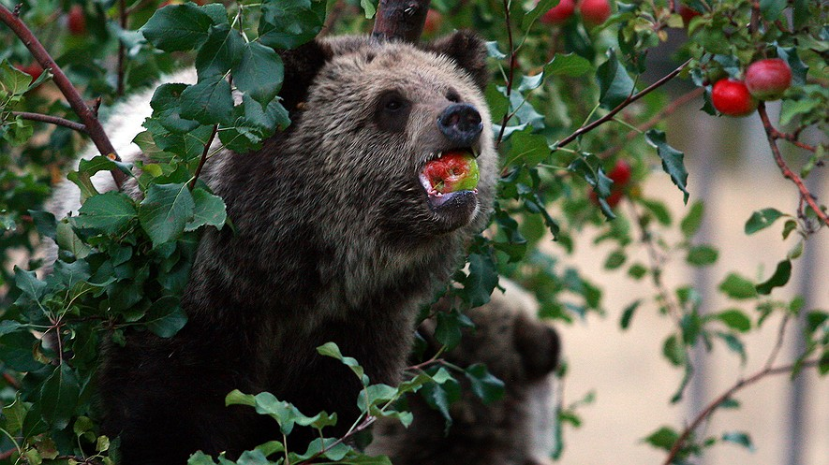
11.30.15

A grizzly bear cub eats apples in a tree a few miles from the north entrance to Yellowstone National Park in Gardiner, Montana, Sept. 25, 2013. Photo: Alan Rogers/The Casper Star-Tribune via AP

BILLINGS, Mont. — American Indian tribes in the Western United States are fighting to protect grizzly bears. The tribes are trying to stop national wildlife officials from ending laws that protect the bears. The grizzlies roam the wilderness in and around Yellowstone National Park. The tribes are worried hunters will kill the bears, which they believe are sacred. The bears are very important to their culture. Most of the grizzly bears in the United States were gone by the early 1900s because hunters had killed so many. Ben Nuvamsa is a leader of Arizona's Hopi Tribe. He says his people think of the grizzly bear as an uncle who has strong healing powers. The grizzly is represented in traditional ceremonies. "We regard him as part of our family, and it's really important to all of us natives to keep him around," Nuvamsa said. "It doesn't matter where the bears are. We pray to them when we see them."
Waiting For The Bear Decision
Government wildlife officials and some scientists say the 700 to 1,000 bears in the area are no longer endangered. When an animal becomes endangered, it means there are so few around that soon there could be none left. The government has been trying for almost 10 years to declare the grizzly as not endangered. The government did declare the grizzly not endangered in 2007. Then a judge reversed that decision two years later. A new decision about whether to take away protection laws for the bears will be made in the next few months. If protective laws are removed, then the states will control how the bears are treated. The states might let trophy hunters kill the bears. Trophy hunting is hunting animals just for sport, and not for food. Officials in Montana, Idaho and Wyoming think hunting the bears could be a good thing.
Grizzlies Are Not Too Shy To Attack
There have been many dangerous events between bears and humans in the 19,000-square-mile Yellowstone region lately. The attacks make the upcoming decision even more difficult. Grizzly bears regularly attack hunters. They also attack animals like cows on ranches outside the park. Because of this, people who work in the ranching business, and state officials, object to protecting the bears. Serena Baker is the spokeswoman for the U.S. Fish and Wildlife agency. It is part of the government. She says the agency will consider both the concerns of the tribes, and science, when they make a decision. The grizzly bear population in the Yellowstone Park area has grown larger since laws protecting them began in 1975. When officials decide if a kind of animal should be protected, they look at the facts. They meet with scientists. Baker said the tribes' views would also be considered. "They have a very deep connection to the land and the animals and the environment," she said. "We certainly want to respect that."
Many Tribes To Voice Their Concerns
Yet leaders of many Native American tribes are angry. They say the government did not ask their opinion about bears. Not asking their opinion breaks treaties between the tribes and the U.S. government. A treaty is an agreement between groups or governments. Grizzly bears once lived across much of the Western part of the country. Hunting made them disappear from most of their historic range in the United States. "These are our treaty lands, our ancestral homelands," said Lee Juan Tyler, a leader of the Shoshone Bannock Tribes. "We want the grizzly bear protected with those lands." Government officials say they have spoken to five tribes in Montana, Idaho and Wyoming. They plan to talk to two other tribes soon. Baker said letters have been sent to more than 50 tribes inviting them to talk about this situation. "We need to hear from them on when and where we can meet, because we are ready to meet at any time," Baker said.
Week 7, Day 1: Read, Annotate (write in the margins: questions, circle unknown words, connections, main idea of each paragraph, etc. ), and Summarize the article.

Week 7, Day 2: Re-read, Annotate using a new color to find the answer to each multiple-choice question. Next to the text annotation, write the question number.

Week 7, Day 3: Re-read the article. Make a t-chart. On the left side record reasons why grizzly bears should be protected and on the right side record reasons why grizzly bears should not be protected.

Week 7, Day 4: Re-read the article, Annotate using a new color to find evidence to answer the question, and Cite evidence from the article to support you answer. Write Multiple Paragraphs. In your opinion, should American Indian tribes fight to keep grizzly bears alive? Use at least three pieces of evidence from the article to support your opinion.

Day 2

1. Which paragraph in the section "Waiting For The Bear Decision" BEST supports the following conclusion?

Changing the law that protects grizzly bears could allow people to hunt the bears for fun.

Underline the evidence from the paragraph that supports the conclusion and write a number 1 next to it.

2. What recent events have caused more concern over the decision of whether to change the law?

a. grizzly bear attacks
b. objections from state officials
c. protests by ranchers
d. grizzly bears being threatened

3. What does the article's introduction [paragraphs 1-4] accomplish?

a. it defines the problem
b. it makes an argument
c. it makes a prediction
d. it summarizes the article

4. Which statement BEST reflects Serena Baker's point of view, based on the sections "Grizzlies Are Not Too Shy To Attack" and "Many Tribes To Voice Their Concerns"?

a. science is more convincing than cultural tradition
b. grizzly bears need to be protected from hunting
c. Native American tribes do not want to discuss the law about grizzly bears
d. the government should carefully consider the Native Americans feelings and beliefs

