Growing Up

Colonial children were trained for the roles they would take on as adults. Circumstances such as gender, age, and social status made a big difference in a young person’s life. Since very few young people in colonial Virginia kept diaries, historians gather evidence from a variety of sources to reconstruct how children spent their days. The following young people offer insights into what their lives might have been like.

Meet Charles (gentry boy)
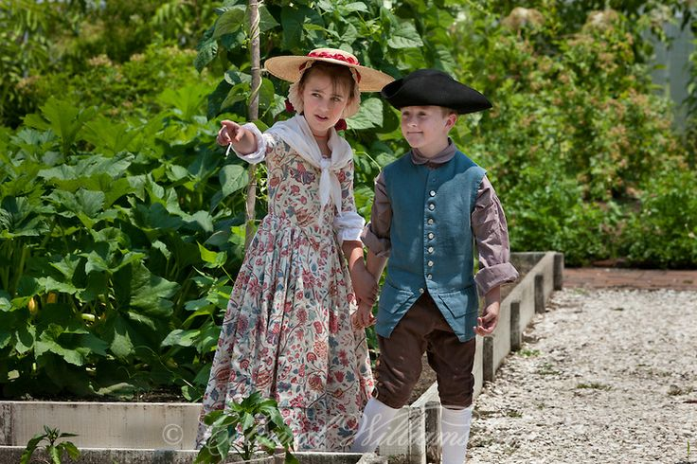
As the oldest son of a plantation owner, Charles has been sent to a boarding school. He is being taught history, geography, and mathematics, as well as how to read and write in English and Latin. While Charles spends most of his waking hours at his studies, time for relaxing is also built into his day. For example, Charles and his fellow students might spend an afternoon fishing, hunting, or horseback riding. Since all gentlemen (and gentlewomen) are expected to be able to carry themselves with grace and dignity and dance well, a dancing master comes twice a week to give them instruction. Charles is also taking fencing lessons. His father plans to send him to England or a colonial college in a few years to complete his education. By the time Charles is 21 years old, he will be prepared to run his own plantation and manage enslaved workers.

Meet Sarah (gentry girl)
Sarah’s father can afford the expense of a private tutor for his family, so Sarah and her four younger siblings are being taught at home. Sometimes the daily routine varies because of visitors, special lessons in music or dance, or other genteel pursuits. Her mother is also teaching her about the planting and harvesting of their large kitchen garden, and showing her how to care for the household poultry. There’s time to relax, too. Sarah might take her younger sisters out for a walk, though only with a chaperone! Sarah also works at her needlework. These skills will come in handy. When Sarah his married, she’ll be responsible for seeing that her family’s clothes are made and repaired, and she will do some of this work herself. When Sarah finishes her lessons in her early teenage years, she will begin a round of extended visits to relatives. She will make a good “match” for a husband and can someday use all she has been taught to oversee her own household,\ raise children, and manage servants.

Meet Alice (middling girl)
As a storekeeper’s daughter, Alice was fortunate to be able to attend the school the minister runs for those who can afford to pay. She also learned how to play the harpsichord. Since she recently turned 14, Alice has been apprenticed to the local milliner where she is provided with food, clothing, and lodging as she learns the trade of making and selling fashionable items and clothing accessories. Before she left home, Alice helped her mother with the cooking, laundry, sewing, gardening, and food preservation. Once, when a neighbor was sick, Alice’s mother brought her along to help care for the neighbor’s children. Knowledge of how to care for sick people is something all young women are taught in colonial America.

Meet Giles (lower boy)
As the son of a poor shoemaker, Giles does not have access to a formal education. He learns only what his father can teach him. He spends most of his days working with his father. Tonight, if he can finish his chores in time, he hopes to meet his friends. He has to be careful, though. Since his mother and baby sister died four months ago of smallpox, his grieving father has had a lot on his mind. He was thinking about sending Giles away to live with relatives in Georgia. If his dad finds out that he was out playing pranks and causing mischief, Giles will get a whipping for sure.

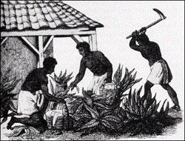
Meet Caesar (enslaved boy)
Caesar lives with his mother, Aggie. His father is a slave on another plantation eight miles away, so they do not see him very often. His older sister was recently given as a gift to the master’s daughter, who lives 50 miles away. His mother is still sad about this and has told Caesar to keep out of trouble and do his chores. The mater’s young daughter has offered to teach Caesar how to read from the Bible and even to write some basic words. But he has little time for education. Caesar is always busy doing cores, such as hauling water from the well, chopping and stacking firewood, or taking care of the livestock. The master also gives him errands to run. The other day, Caesar heard the master talking about arranging him to learn how to become a carpenter. That would be better than working in the fields from sunup to sundown. Although he is often tired at night, Caesar looks forward to the evenings when the slave community comes together to sing and dance, and tell stories.

Week 4, Day 1: Read, Annotate (write in the margins: questions, circle unknown words, connections, main idea of each paragraph, etc. ), and Summarize the role of the gentry, middling, and slave.

Week 4, Day 2: Re-read the Gentry Boy (Charles) and Gentry Girl (Sarah). Compare and contrast the expectations for boys vs. girls in the Gentry class. Provide at least 2 pieces of evidence from the text on how they are similar, and at least 2 pieces of evidence from the text on how they are different.

Week 4, Day 3: Re-read the article. Why would the separate classes have different expectations? Judge the value of this social class system. Provide at least 2 examples from the text in your response.

Week 4, Day 4: Re-read the article. Annotate using a new color to find evidence to answer the question, and Cite evidence from the article to support you answer. Write Multiple Paragraphs. Based on what you’ve read about the Gentry, Middle, and Lower class, how would you feel if you were a slave relative to the other classes? Use at least three pieces of evidence from the article to support your opinion.

