Name _____________________________ #_________ Date__________________

1. Sebastian stores his baseball cards in a box like this one.
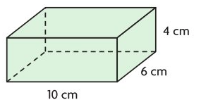
Use the numbers and symbols below to enter a formula that represents the volume of the box.
Symbols may be used more than once or not at all.
V 4 6 10 × ÷ + −
The formula for the volume of the box is _____ = _____ ☐ _____ ☐ _____

The volume of the box is __________ cubic centimeters.

2. What is the volume of the composite figure?

The volume of the composite figure is _________ cubic feet.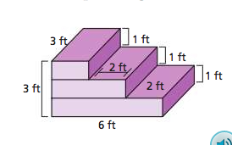
3.
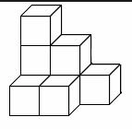 ______ unit cubes would be needed to build the figure.
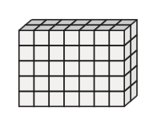 ______ unit cubes would be needed to build the figure.
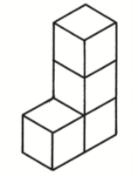 ______ unit cubes would be needed to build the figure.

4. Gianna used 1-inch cubes to build the rectangular prism shown.
Find the volume of the rectangular prism Gianna built.

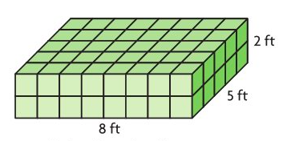

The volume of the rectangular prism Gianna

built is __________ cubic centimeters.

