Name _____________________________ #_________ Date__________________

1. A shipping crate holds 20 shoeboxes. The dimensions of a shoebox are 5 inches by 4 inches by 12 inches. For number 1a-1b, circle True or False for each statement.
1a. Each shoebox has a volume of 21 cubic inches. True False
1b. Each crate has a volume of about 500 cubic inches. True False
1c. If the crate could hold 29 shoeboxes the volume of
the crate would be about 6,960 cubic inches. True False

2. Lauryn is making a diagram that shows the relationship between different kinds of quadrilaterals. In the diagram, each quadrilateral on a lower level can also be described by the quadrilateral(s) above on higher levels.
Part A: Complete the diamgram by writing the name of one figure from the tiles in each box. Not every figure will be used.
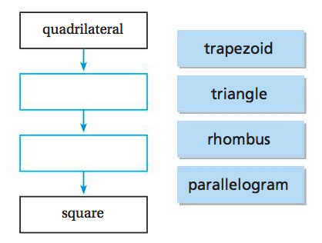
Part B: Lauryn claims that a rhombus is sometimes a square, but a square is always a rhombus. Is she correct?
(circle the correct answer) Yes / No. A square has __________________ that are congruent and equal. A square with these features is also a rhombus.
However, when a rhombus does not have ______________________, It is not a square.

3. Adam packed 1-inch cubes into a box with a volume of 360 cubic inches. How many layers of 1-inch cubes did Adam pack?
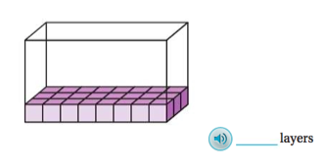

4. 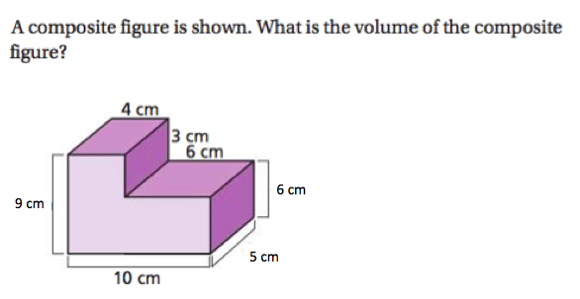

The volume of the composite figure is _______________ cubic centimeters.

