Name _____________________________ #_________ Date__________________

1. Select the name of the quadrilateral from below to complete the true statements.
Use each quadrilateral only once.
Square Trapezoid Rectangle

1a. ________________ is never a parallelogram.

1b. ________________ is always a parallelogram.

1c. ________________ is always a rhombus.

2. 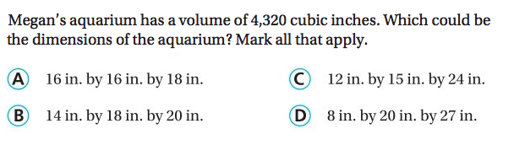

3. Kian keeps paper clips in a box that is the shape of a cube. Each side is 8 inches. What is the volume of the box?

The volume of the box is ______________ cubic inches.

4.
