As the World Changes, Schools Must Change, Too
By Project Syndicate, adapted by Newsela staff
01.12.16
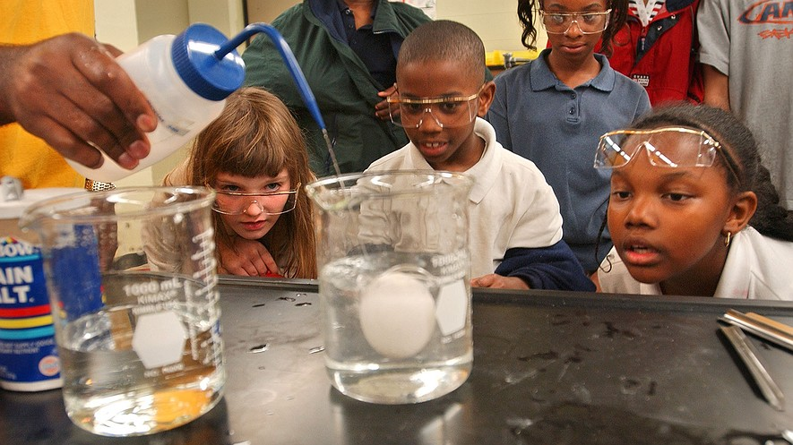
Lowndes County Middle School students (from left) Lauren Starks, Antonio Davis, Caitlyn Gilkey and Ashley Starks watch as University of Mississippi doctoral candidate Murrell Godfrey dilutes salt water with tap water, causing an uncooked egg to sink during a chemistry magic show in Coulter Hall on the university's campus, April 24, 2003. Photo: AP/Robert Jordan

PARIS, France — The Industrial Revolution changed the world. The Revolution took place in the 1700s and 1800s and was a time when many important technological advances were made. It made it easier for everyone to benefit from new inventions and ideas. However, even though technology became more common, many people did not have the training to use it. Technology sped up, but not enough people could get a good education. Since then, leaders have been trying to figure out how to make sure everyone gets a good education.
One solution is through universal access to education. With universal access to education, everyone has the opportunity to go to school. It took about a hundred years for the idea of universal access to schooling to spread to countries around the world. People in today's world are much more educated than they were hundreds of years ago. Even though many more kids have access to school than they used to, there is more work to be done. Lawmakers and leaders must make sure that everyone can get high-quality education.
Education Can Lead To Better Lives
The world is no longer as divided as it used to be. There used to be a clear division between rich, well-educated countries and poor, badly educated ones. Education can help bridge these differences. When countries spend money to improve the quality of their education system, their people's lives improve.
Yet even in rich countries, the quality of education needs to be improved.
The quality of a nation's education system is important. Education can affect a nation's economy in different ways. An economy is the amount of wealth and jobs a country has. In fact, education is a part of the human development index. The index uses several factors to rank countries. It measures the quality of life of the people who live around the world. The index shows that being able to read leads to better lives. For example, adults who cannot read face challenges that literate people do not. Adults with low literacy skills are far more likely to have health problems. They also trust other people less and feel less in control of their lives.
Students Must Be Prepared For Jobs
It is not just enough to make sure that everyone goes to school. It is just as important to teach students the skills they actually need. Countries must make sure that their schools prepare students for jobs.
Today, knowledge is still important. But it is easy for anyone to find information on the Internet. So, it is the students who know how to use that information who succeed in the workforce.
Schools must also teach students how to see patterns among different pieces of information. Successful countries train students to be curious and to ask questions. Educators should inspire their students to make connections between different ideas.
Learning Teamwork Is Important
Another important factor is teamwork. Workers today must be able to get along with others and work together. Big ideas today rarely come from people working alone. Instead, new ideas come from sharing and working together. Schools should give students the opportunity to connect with other students and learn about how to deal with different opinions.
As lawmakers think about improving today's schools, they should focus on jobs. While grades are important, so is being able to succeed in the workforce. Teachers can help prepare their students for life after school, too. One way to do that is to provide students services that make it easier to find and keep jobs. Educators should also teach skills that are useful in work, like teamwork and communication.
As technology changes around us, the education system must change, too. It will not be easy to fix the education system. Nevertheless, it is an important goal. Governments, teachers and businesses will all need to pitch in.
In the end, the future of education depends on students. Individuals must also step up. Students need to take advantage of opportunities to build their own futures.

Week 3, Day 1: Read, Annotate (write in the margins: questions, circle unknown words, connections, main idea of each paragraph, etc. ), and Summarize the article.

Week 3, Day 2: No Hot Topic. You are practicing your speech. You and your parents are filling out the page handed out today!

Week 3, Day 3: Re-read the article. Make a t-chart. On the left side record at least 4 reasons why the world must change, and on the right side record at least 4 reasons why the world must not change.

Week 3, Day 3: Re-read the article, Annotate using a new color to find evidence to answer the question, and Cite evidence from the article to support you answer. Write Multiple Paragraphs. In your opinion, as the world changes, must schools change too? Use at least three pieces of evidence from the article to support your opinion.

