Top Video Gamers Find Fame Playing with Big Crowds for Prize Money

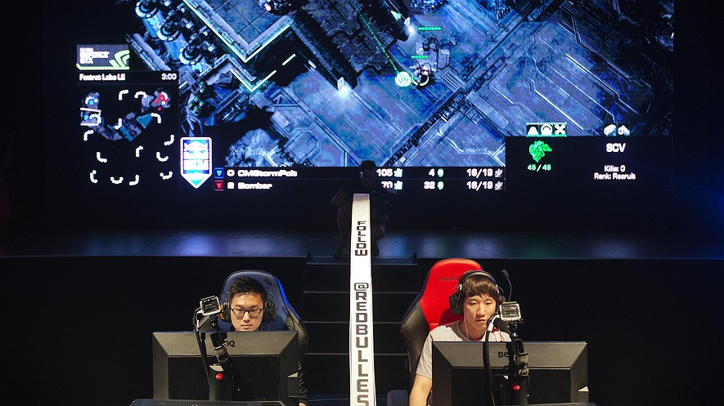
By Washington Post, adapted by Newsela staff
09.29.15
Lexile 820

Choi Seong Hun (left), who goes by the gaming name "PoLt" and Choi Ji Sung, known as "Bomber," both of South Korea, are separated by a divider as they compete against each other in the finals of the Red Bull Battle Grounds "StarCraft II" video game tournament in Atlanta, Georgia, July 13, 2014. Photo: AP Photo/David Goldman

The earliest computer games were not played online. People played alone or with just a few friends. Then, the Internet connected players from around the world.
Players still remained alone in their bedrooms and basements, however. They played against many more people, but they still rarely got to know them in real life.
Things have certainly changed since then. Gaming has become like any other sport, and the top players now play in matches held in front of cheering crowds.
On Saturday, the Fillmore theater in Silver Spring, Maryland, was packed. The crowd was there to watch the Red Bull Battle Grounds championship games, which featured a group of top gamers.
As the players filed onto the stage, the audience began cheering. Fans waved posters with pictures of their favorite players on them.

New StarCraft Game Allows Teams
The players then began warming up. One changed the height of his chair, while another put a neck pillow on the back of his chair for extra cushioning. Another rolled his neck and moved his shoulders up and down to get loose.
Once everyone was ready the games began. The gamers were playing a new form of the game StarCraft, which now lets teams of two play against each other. They tapped away at keyboards and tried to kill their enemies.
The first match was particularly exciting. Choi Ji Sung and Mun Seong Won made up one of the teams. Choi is known as "Bomber" and Mun is called "MMA." Chris Loranger and Jang Min Chul were on the other team. Loranger is called "Huk" and Jang is known as "M.C."
Bomber was the winner of the last big games and was hoping to win again. M.C. had come out of retirement to see if he could beat Bomber this time around.

Fans Travel Far To See Games
The fans in the audience had come from all over the country to see the games.
Kyle Storey traveled from Dover, New Hampshire, with his best friend, Edward Juarez. The two came to watch Bomber and were hoping to see him win again.
Sounil Yu and his two teenage sons came from Reston, Virginia, to watch the games. The three like to play StarCraft together. Yu and his sons said they think StarCraft is one of the hardest computer games. Players have to pay attention to a lot of different things all at the same time. For example, they have to mine minerals and build worker bases while they are fighting their enemies.
StarCraft is "like chess but much faster and much more interesting to watch," Yu said.
John Bain was once a big gamer, and is known as TotalBiscuit. Bain now makes a living talking about other gamers, and to fans. More than 2 million people watch his YouTube channel.

Big Matches Have "Gamescasters"
Bain also "gamescasts" live matches these days. He is like a sportscaster who talks about plays at a football or baseball game.
Bain was one of four "gamescasters" who were at Saturday's Red Bull tournament. He thinks the move to holding big games in halls and theaters is a very good thing.
In the past, gamers never really met the people they played against or many fellow fans of the game, Bain said. Now people can get out of their bedrooms and basements and meet each other.
Jessica Yuen was another one of the excited fans who watched Saturday's games. She came from New Jersey together with the members of her old college StarCraft club, many of whom are still among her best friends. Yuen also counts gamers she's met online as among her closest friends.
She was rooting for Huk, whose playing she has followed for years. She likes Huk for more than his gaming skills.
"He's just a nice guy. He cares about his fans," Yuen said.
In the end, Yuen got her wish. After seven hours of matches, Huk and M.C. won the tournament.

Week 2, Day 3: Read, Annotate (mini main idea for each paragraph in the margins), and write a Summary of the article.

Week 2, Day 4: Re-read the article, Annotate using a new color, and Cite evidence from the article to support you answer. If you were going to add another picture or a chart to this article to help readers better understand an important point, what would it be and why?

